Project Development Phase
Model Performance Test

Date
Team ID | SWTID-2026-1809
Project Name | Enforcing Mandatory Fields Using UI Policies and Migrating Changes with Update Sets
Maximum Marks

Model Performance Testing:
Project team shall fill the following information in model performance testing template.
S.No. | Parameter | Values | Screenshot
 | Metrics | Regression Model:  MAE – Not Applicable  MSE – Not Applicable  RMSE – Not Applicable  R² Score – Not Applicable  Classification Model:  Confusion Matrix – Not Applicable  Accuracy Score – Not Applicable  Classification Report – Not Applicable  Reason: This project is based on ServiceNow configuration (UI Policies & Update Sets) and does not involve machine learning models. | 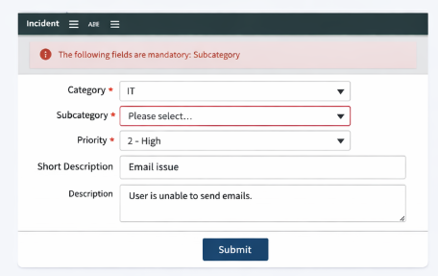
 | Tune the Model | Hyperparameter Tuning: Not Applicable  Validation Method:  • Functional Testing – Verified mandatory fields work correctly based on conditions  • User Testing – Ensured users cannot submit forms without required data  • Migration Testing – Validated Update Sets successfully move changes between instances (Dev → Test → Production) | 